Below is the steps to Guide the installation of jenkins

==================================================================================

[root@ip-172-31-9-230 ~]# yum update -y

Last metadata expiration check: 0:10:10 ago on Sat 09 Nov 2019 06:23:37 AM UTC.

Dependencies resolved.

Nothing to do.

Complete!

[root@ip-172-31-9-230 ~]# curl --silent --location http://pkg.jenkins-ci.org/redhat-stable/jenkins.repo | sudo tee /etc/yum.repos.d/jenkins.repo

[jenkins]

name=Jenkins-stable

baseurl=http://pkg.jenkins.io/redhat-stable

gpgcheck=1

[root@ip-172-31-9-230 ~]# sudo rpm --import https://jenkins-ci.org/redhat/jenkins-ci.org.key

[root@ip-172-31-9-230 ~]# yum install jenkins

Jenkins-stable 21 kB/s | 16 kB 00:00

Dependencies resolved.

==================================================================================

Package Architecture Version Repository Size

==========================================================================================================================

Installing:

jenkins noarch 2.190.2-1.1 jenkins 74 M

Transaction Summary

==========================================================================================================================

Install 1 Package

Total download size: 74 M

Installed size: 75 M

Is this ok [y/N]: Y

Downloading Packages:

jenkins-2.190.2-1.1.noarch.rpm 1.9 MB/s | 74 MB 00:39

--------------------------------------------------------------------------------------------------------------------------

Total 1.9 MB/s | 74 MB 00:39

Running transaction check

Transaction check succeeded.

Running transaction test

Transaction test succeeded.

Running transaction

Preparing : 1/1

Running scriptlet: jenkins-2.190.2-1.1.noarch 1/1

Installing : jenkins-2.190.2-1.1.noarch 1/1

Running scriptlet: jenkins-2.190.2-1.1.noarch 1/1

Verifying : jenkins-2.190.2-1.1.noarch 1/1

Installed:

jenkins-2.190.2-1.1.noarch

Complete!

[root@ip-172-31-9-230 ~]# systemctl start jenkins

[root@ip-172-31-9-230 ~]# systemctl status jenkins

● jenkins.service - LSB: Jenkins Automation Server

Loaded: loaded (/etc/rc.d/init.d/jenkins; generated)

Active: active (running) since Sat 2019-11-09 06:37:05 UTC; 7s ago

Docs: man:systemd-sysv-generator(8)

Process: 16020 ExecStart=/etc/rc.d/init.d/jenkins start (code=exited, status=0/SUCCESS)

Tasks: 25 (limit: 4998)

Memory: 234.3M

CGroup: /system.slice/jenkins.service

└─16041 /etc/alternatives/java -Dcom.sun.akuma.Daemon=daemonized -Djava.awt.headless=true -DJENKINS_HOME=/var/>

Nov 09 06:37:04 ip-172-31-9-230.ap-south-1.compute.internal systemd[1]: Starting LSB: Jenkins Automation Server...

Nov 09 06:37:04 ip-172-31-9-230.ap-south-1.compute.internal runuser[16027]: pam_unix(runuser:session): session opened for>

Nov 09 06:37:05 ip-172-31-9-230.ap-south-1.compute.internal runuser[16027]: pam_unix(runuser:session): session closed for>

Nov 09 06:37:05 ip-172-31-9-230.ap-south-1.compute.internal jenkins[16020]: Starting Jenkins [ OK ]

Nov 09 06:37:05 ip-172-31-9-230.ap-south-1.compute.internal systemd[1]: Started LSB: Jenkins Automation Server.

==================================================================================

Below is the screenshot of the Jenkins server accessed first time without configuring the port 8080

Into the AWS secutiry group now we will configure it and access it again.

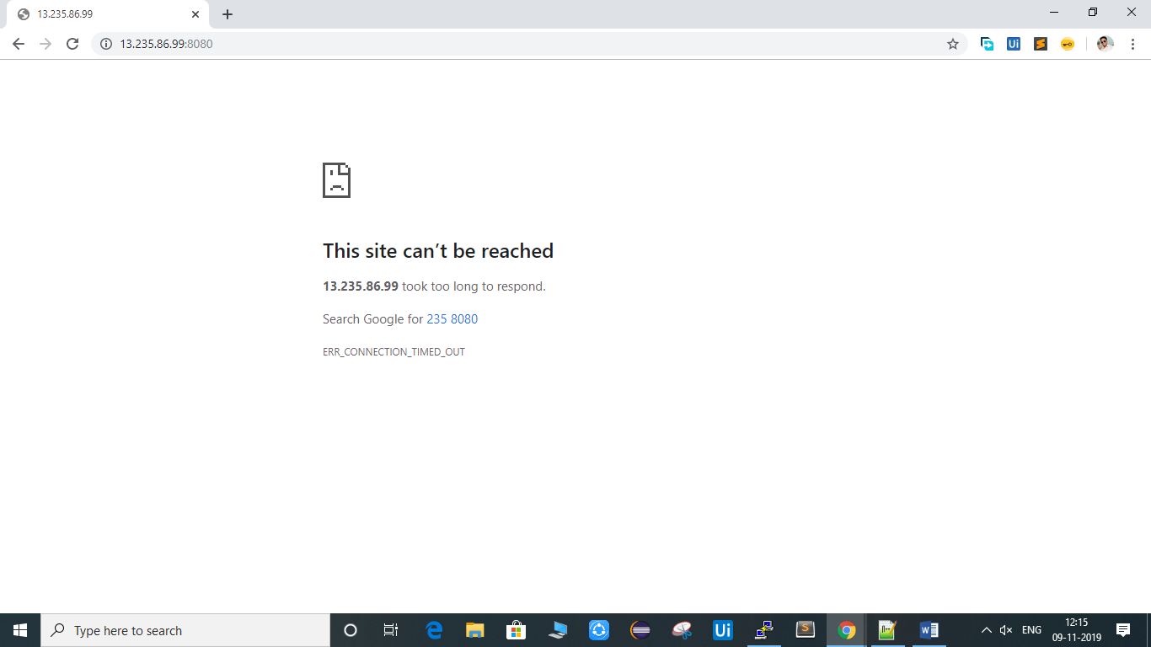

GO to below page

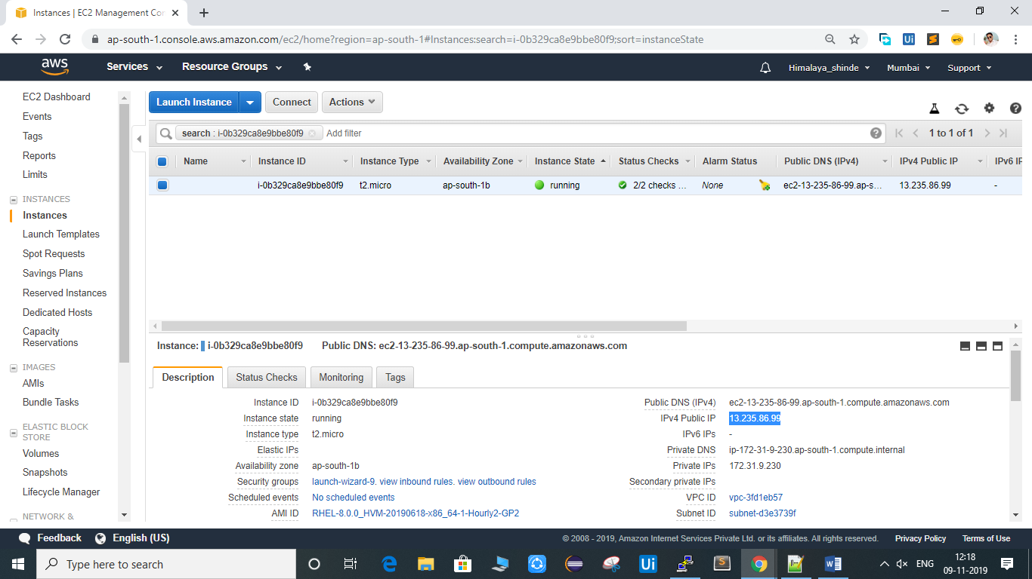

Click on the security group url shown in above image in your aws account.

Then page will come click on inbound to see the similar page as below.

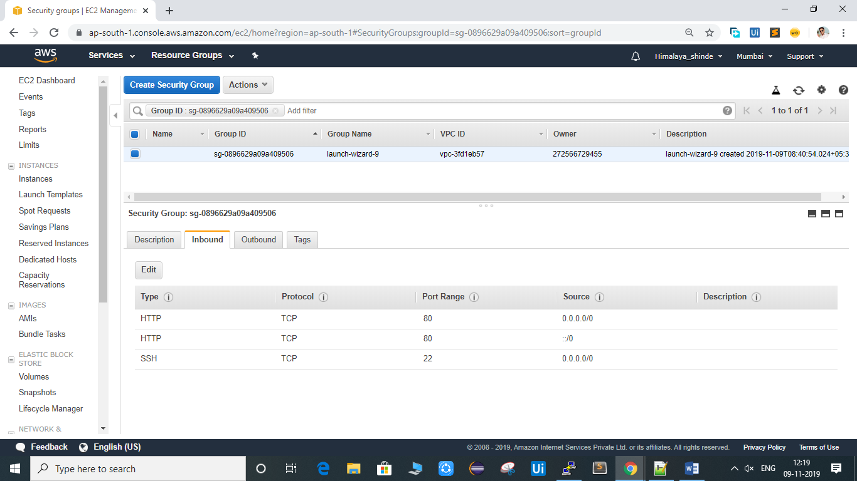

Now click on edit and add the custom page as below image and save the changes.

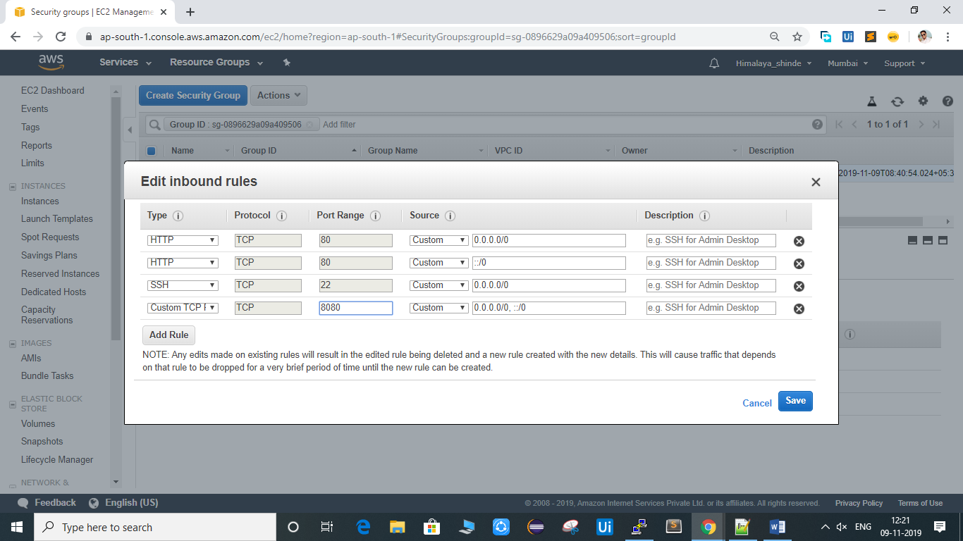

And now refresh the URL accessed on first attempt.

You will get the below page

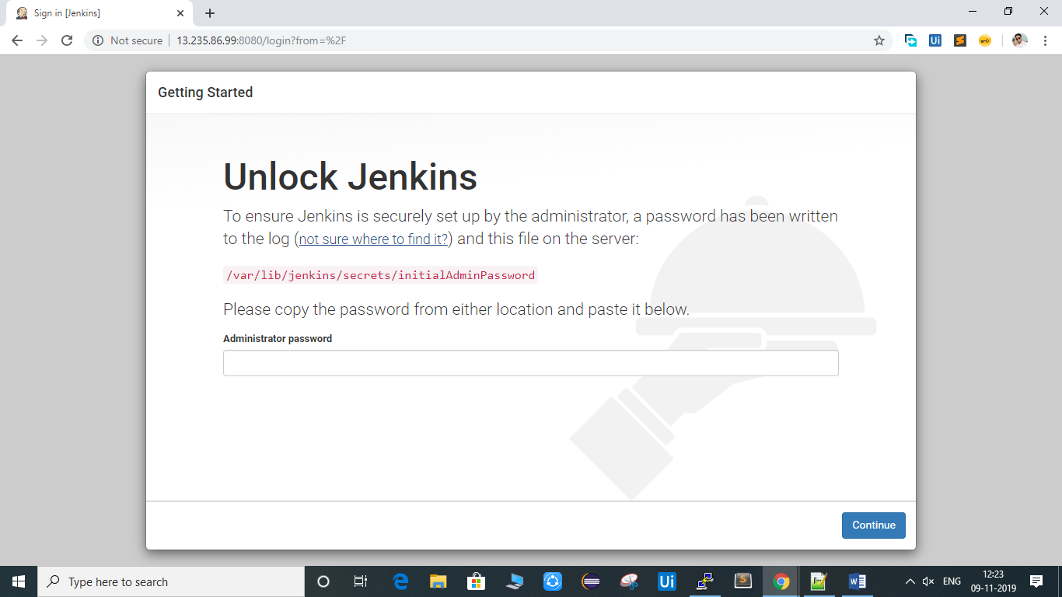

Now copy the path mentioned on the webpage.

[root@ip-172-31-9-230 ~]# cat /var/lib/jenkins/secrets/initialAdminPassword

102141465ff043b0a52ea38162d0fa52

Now paste the password generated into the above page and continue

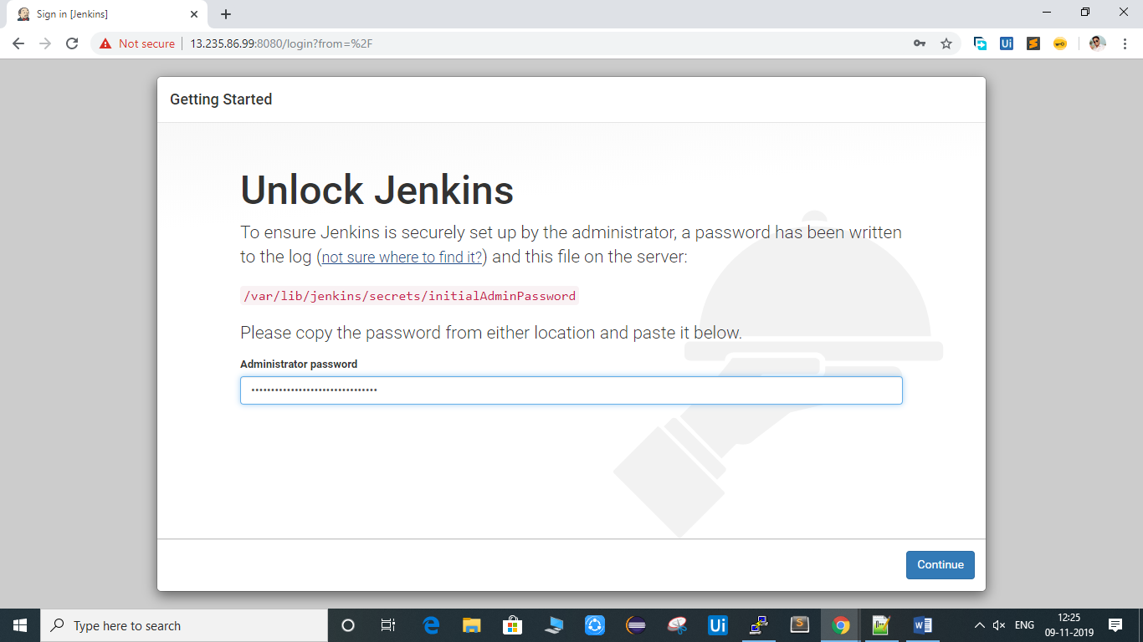

You will get the below page

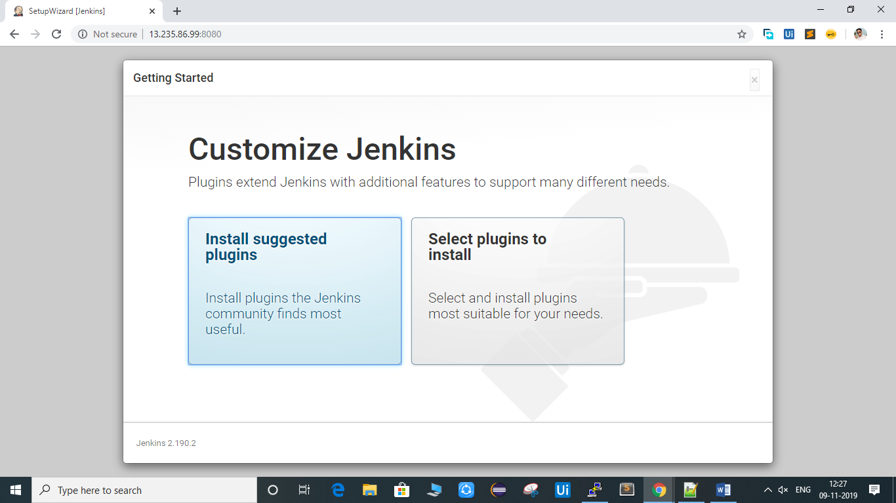

Click on install suggested plugins if you don’t know which are recommended or required for your use.

Your installation will begin after the click like this.

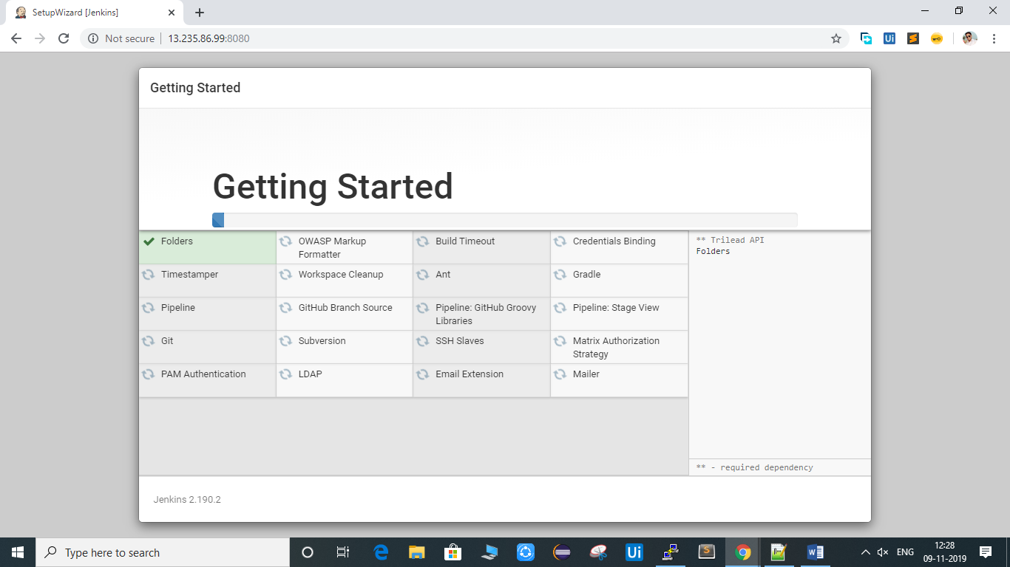

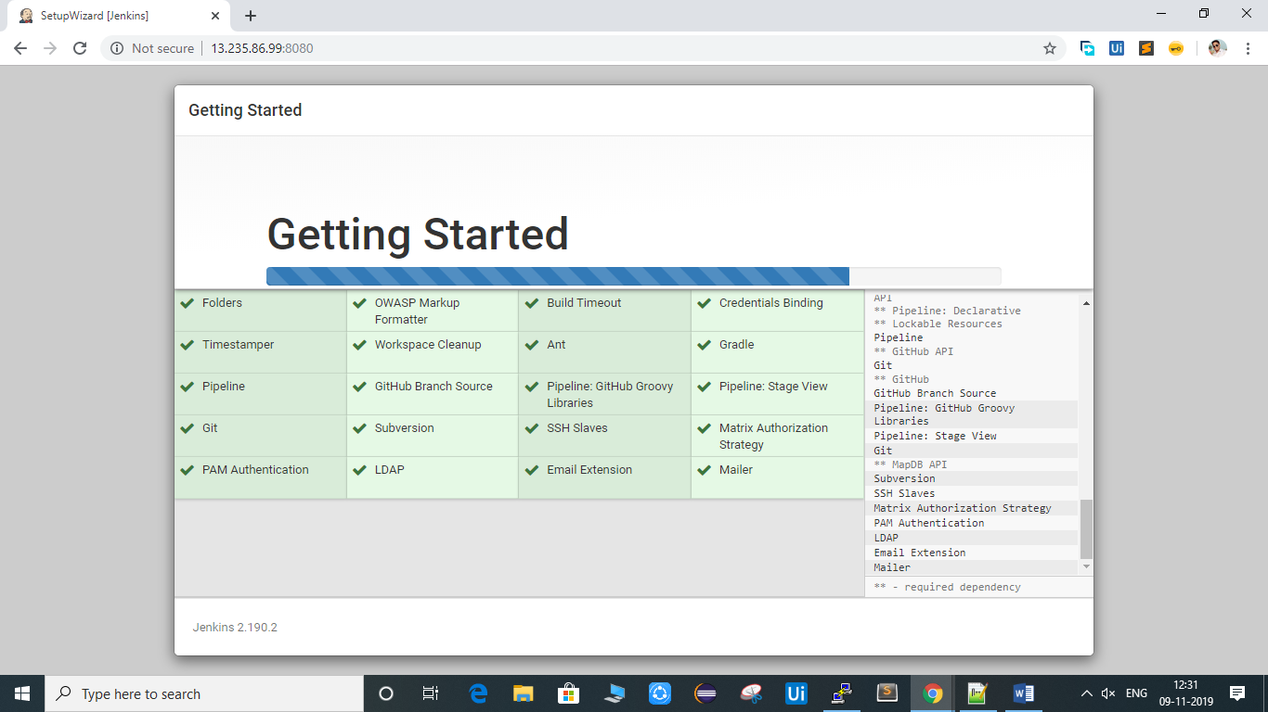

After this it will ask for the admin user info like below fill this and get started with jenkins.

